Statement
Dear CultureFly Management,

We would like to inform you that Relay Packaging Technology & Solution is a subsidiary company of Recall Supermix Packaging Hongkong Limited.
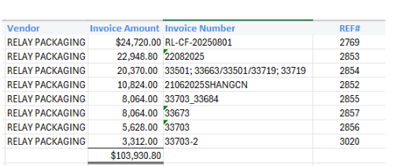
We would like payment of below invoices shipped under the name of “Relay Packaging Technology & Solution” be sent to “Recall Supermix Packaging Hongkong Limited.”

Total amount: $103,930.80

Deduct
PUQ042A- 2.80/PC - TOTAL 7320PCS RECEIVED = $ 20,496.00
Bellow are freight , duty , trucking fee - 20396.64
Total cost = $20,496.00+$20,396.64= $40,892.64
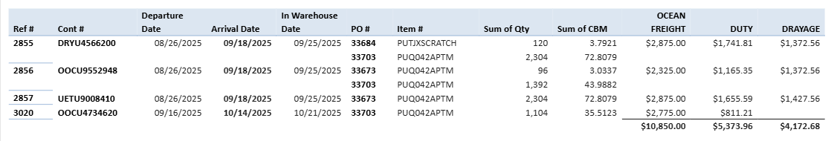
Payment: $103,930.80-$40892.64 =$63,038.16

Remittance details:
Company Name：RECALL SUPERMIX PACKAGING HONGKONG LIMITED
Company account：111900831
Bank Name：OCBC Bank (Hong Kong) Limited
Bank Code：035
Branch Code：802
SWIFT Code：WIHBHKHH
Bank Address：161 Queen's Road Central Hong Kong
Company Address: Room 701, Unit 127, 7/F, Tower B New Mandarin Plaza,14 Science Museum Road, Tsim Sha Tsui, Kowloon

I hereby declare that the Statement and information provided above is true and correct.


Sincerely,

Relay Packaging Technology & Solution
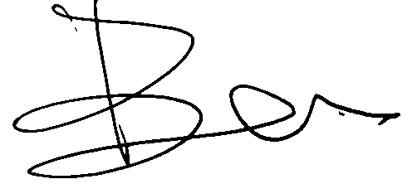
Director name: Ben
Signature:
Date: March 9, 2026, 2026

